Q) What is DBMS?
Q) Why DBMS?
Q) What is RDMS?
Q) What are the types of SQL commands?
Ans:
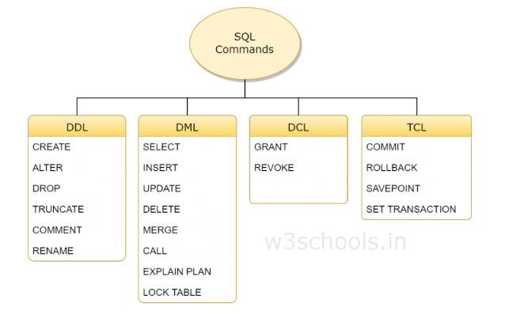

DDL
DDL is short name of Data Definition Language, which deals with database schemas and descriptions, of how the data should reside in the database.
- CREATE - to create a database and its objects like (table, index, views, store procedure, function, and triggers)
- ALTER - alters the structure of the existing database
- DROP - delete objects from the database
- TRUNCATE - remove all records from a table, including all spaces allocated for the records are removed
- COMMENT - add comments to the data dictionary
- RENAME - rename an object

DML
DML is short name of Data Manipulation Language which deals with data manipulation and includes most common SQL statements such SELECT, INSERT, UPDATE, DELETE, etc., and it is used to store, modify, retrieve, delete and update data in a database.
- SELECT - retrieve data from a database
- INSERT - insert data into a table
- UPDATE - updates existing data within a table
- DELETE - Delete all records from a database table
- MERGE - UPSERT operation (insert or update)
- CALL - call a PL/SQL or Java subprogram
- EXPLAIN PLAN - interpretation of the data access path
- LOCK TABLE - concurrency Control

Syntax:

DCL
DCL is short name of Data Control Language which includes commands such as GRANT and mostly concerned with rights, permissions and other controls of the database system.
- GRANT - allow users access privileges to the database
- REVOKE - withdraw users access privileges given by using the GRANT command

TCL
TCL is short name of Transaction Control Language which deals with a transaction within a database.
- COMMIT - commits a Transaction
- ROLLBACK - rollback a transaction in case of any error occurs
- SAVEPOINT - to rollback the transaction making points within groups
- SET TRANSACTION - specify characteristics of the transaction

DML
select name, dept from employee;
select * from employee;
select distinct dept from employee; //Selects distinct values of the Column Specified

A bit modifications to the Where,
SELECT * FROM Customers WHERE Country='Germany' AND City='Berlin';
SELECT * FROM Customers WHERE City='Berlin' OR City='München';
SELECT * FROM Customers WHERE NOT Country='Germany';

Combining,
SELECT * FROM Customers WHERE Country='Germany' AND (City='Berlin' OR City='München');
SELECT * FROM Customers WHERE NOT Country='Germany' AND NOT Country='USA';

OrderBy,
select * from employee order by empid desc;
SELECT * FROM Customers ORDER BY Country ASC, CustomerName DESC;

Testing Null Valuse of a row
SELECT LastName, FirstName, Address FROM Persons WHERE Address IS NULL;
SELECT LastName, FirstName FROM Persons WHERE Address IS NOT NULL;

insert into employee values(1,'Raju','IT'),(2,'Ram','IT'),(4,'Ketan','Mobile');
insert into employee values(5,'Raju','Development'),(7,'Ram','Automation'),(8,'Ketan','Development');
INSERT INTO Customers (CustomerName, ContactName) VALUES ('Cardinal', 'Tom Erichsen');

update employee set dept='Automation' where empid=2;
update employee set dept='Automation' ; //for updating all the rows in a column

delete from employee where empid=7

DDL
CREATE DATABASE testDB;
DROP DATABASE testDB;
create table Employee (empid int,name varchar(20),dept varchar(20));
DROP TABLE Shippers;
alter table employee add designation varchar(20); //add a column
alter table employee drop column designation; //delete a column
alter table employee modify column designation varchar(20) ; // change the datatype of a column

SQL Joins:
A join clause is used to combine rows from two or more tables,based on a related column between them.

Different Types of SQL JOINs
Here are the different types of the JOINs in SQL:
- (INNER) JOIN: Returns records that have matching values in both tables
- LEFT (OUTER) JOIN: Return all records from the left table, and the matched records from the right table
- RIGHT (OUTER) JOIN: Return all records from the right table, and the matched records from the left table
- FULL (OUTER) JOIN: Return all records when there is a match in either left or right table
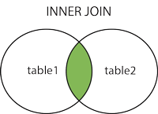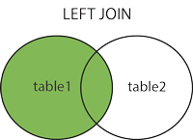
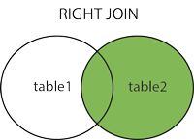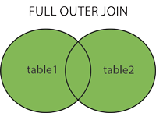

Create Dept Table:
Create table Dept(Dept_Id int not null,Dept_Name varchar(20), primary key(Dept_Id))
Field | Type | Null | Key | Default | Extra
Dept_Id | int(11) | NO | PRI | NULL
Dept_Name | varchar(20) | YES |  | NULL
insert into dept values(10,"Accounts"),(20,"Sales"),(30,'IT')
Dept_Id | Dept_Name
10 | Accounts
20 | Sales
30 | IT

Create Employee Table:
Create table Employee(Emp_Id int not null ,Emp_Name varchar(30), Dept_Id int,Salary double,primary key(Emp_Id),foreign key(Dept_Id) references Dept(Dept_Id) )

Field | Type | Null | Key | Default | Extra
Emp_Id | int(11) | NO | PRI | NULL
Emp_Name | varchar(30) | YES |  | NULL
Dept_Id | int(11) | YES | MUL | NULL
Salary | double | YES |  | NULL
insert into employee values (100,"Ram",10,10000),(101,"Shyam",20,15000),(102,"Jadu",20,11000)
Emp_Id | Emp_Name | Dept_Id | Salary
100 | Ram | 10 | 10000
101 | Shyam | 20 | 15000
102 | Jadu | 20 | 11000

(Inner) Join
Select E.emp_id,E.emp_name,D.dept_name from employee E ,dept D where E.dept_id=D.dept_id
emp_id | emp_name | dept_name
100 | Ram | Accounts
101 | Shyam | Sales
102 | Jadu | Sales

LEFT (OUTER) JOIN:
Select E.emp_id,E.emp_name,d.dept_name from employee E left join dept D on E.dept_id=D.dept_id

emp_id | emp_name | dept_name
100 | Ram | Accounts
101 | Shyam | Sales
102 | Jadu | Sales

RIGHT (OUTER) JOIN
Select E.emp_id,E.emp_name,d.dept_name from employee E right join dept D on E.dept_id=D.dept_id

emp_id | emp_name | dept_name
100 | Ram | Accounts
101 | Shyam | Sales
102 | Jadu | Sales
NULL | NULL | IT

FULL (OUTER) JOIN
For SQL
Select E.emp_id,E.emp_name,d.dept_name from employee E full outer join dept D on E.dept_id=D.dept_id
For MySQL
SELECT * FROM employee e
LEFT JOIN dept d ON e.dept_id = d.dept_id
UNION
SELECT * FROM employee e
RIGHT JOIN dept d ON e.dept_id = d.dept_id

Emp_Id | Emp_Name | Dept_Id | Salary | Dept_Id | Dept_Name
100 | Ram | 10 | 10000 | 10 | Accounts
101 | Shyam | 20 | 15000 | 20 | Sales
102 | Jadu | 20 | 11000 | 20 | Sales
NULL | NULL | NULL | NULL | 30 | IT

Three Table join

Exercise:
Subquery:
Select title from film where film_id in (Select film_id from film_actor where actor_id=(select actor_id from actor where first_name='ED' And last_name='CHASE'))

Create Table:
Create table Employee (empid int auto_increment primary key,name varchar(20),dept_id int,salary long)

Complete Cartesion Product :
select e.name,e.name,e.dept_id,d.dept_name from employee e inner join dept d

